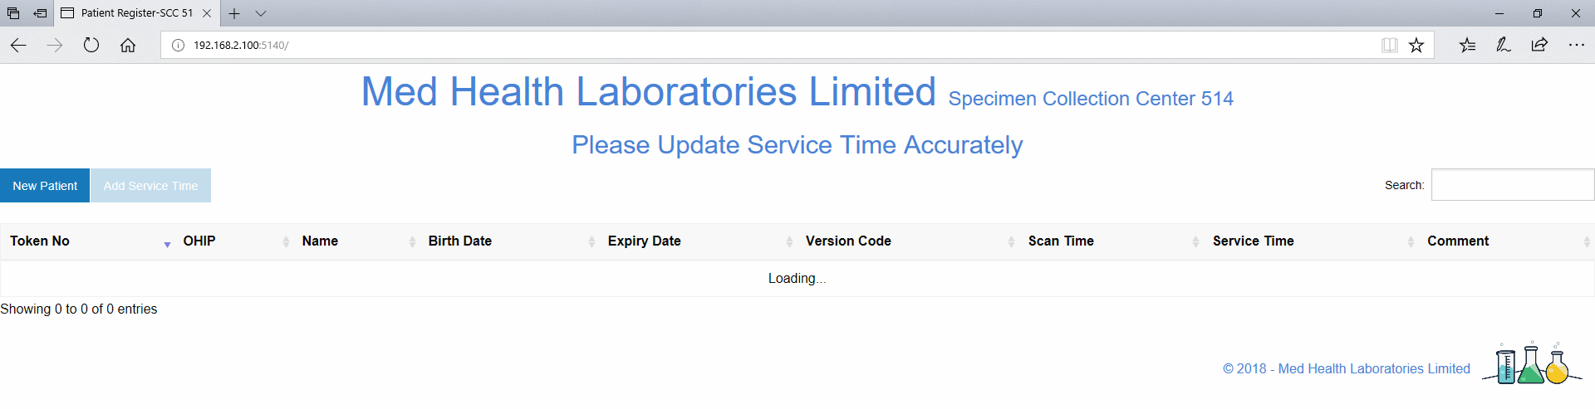

Figure 1 Main Screen

**Step 1:** Open the browser and type URL: **192.168.2.100:5140**

Click on “**New Patient**” Button and present the OHIP barcode near scanner. (If patient doesn’t have the OHIP card or Red & White Health Card, then enter the data manually in the form).

Scan the OHIP card as soon as Patient walks in the door.

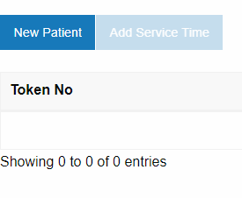

Figure 2 New Patient Button

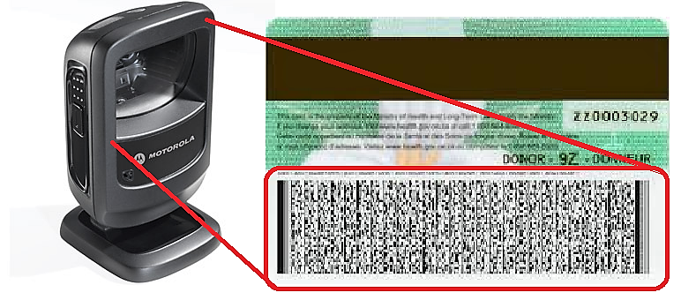

Figure 3 Present Barcode Near Scanner

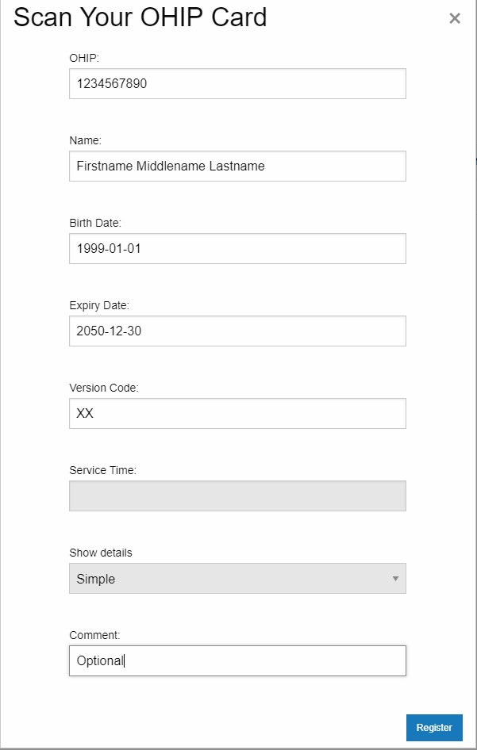

Figure 4 Registration Form

**Step2**: Patient is asked to take a seat & meanwhile complete the data entry in Schuylab.

**Step3:** Call Patient for Phlebotomy whenever ready, Click the “**Add Service Time**” button. If patient can’t perform any tests, then comment ‘Discard’.

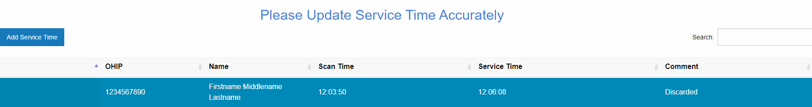

Figure 5 Add Service Time Button

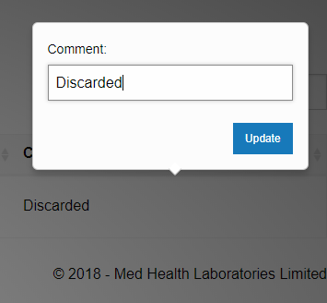

Figure 6 Comment